**Exercise 1:**

1. To prove that $q_{1}^{T}x(t)$ is a constant of motion, we have to take the derivatative w.r.t time and prove it equal to zero.

$$\frac{d(q_{1}^{T}x)}{dt}= q_{1}^{T}\dot{x}$$

We know that $\dot{x}=-Lx$, then

$$\frac{d(q_{1}^{T}x)}{dt}= {-q}_{1}^{T}Lx$$

Also, $q_{1}^{T}L=0$.

Since, $q_{1}^{T}$ is left eigen vector of $L$. Therefore,

$$\frac{d(q_{1}^{T}x)}{dt}=0$$

This proves that $q_{1}^{T}x(t)$ is a constant of motion.

1. Graphs (a), (b) and (d) will converge because all the three graphs contain rooted out branching. Yes, the **consensus value** depends on the initial condition. **However, the convergence(whether the graph will converge or not) doesn’t depend on the initial condition.**
2. For graph (a):

Initial condition = [20, 10, 15, 12, 30, 12, 15, 16]

Agreed Value = [15.5]

For graph (b):

Initial condition = [20, 10, 15, 12, 30, 12, 15, 16]

Agreed Value = [20]

For graph (d):

Initial condition = [20, 10, 15, 12, 30, 12, 15, 16]

Agreed Value = [16.25]

1. For the code please refer to the *“hw2_1_3.py”* file

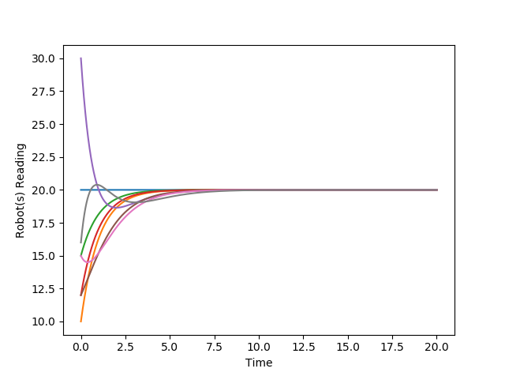Following the plots:

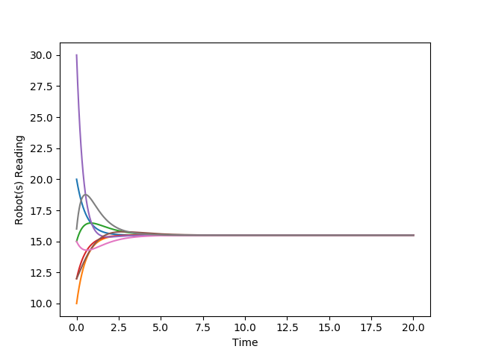Graph (a) Graph (b)

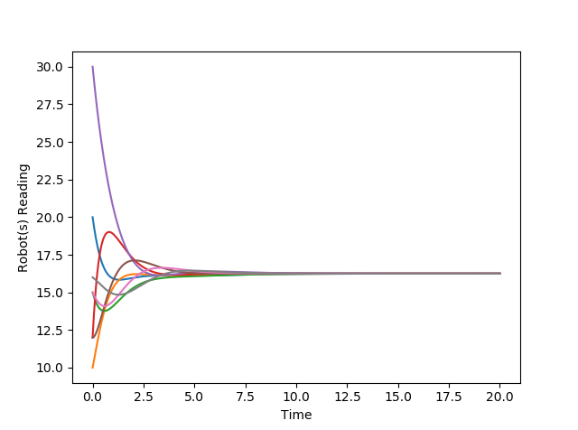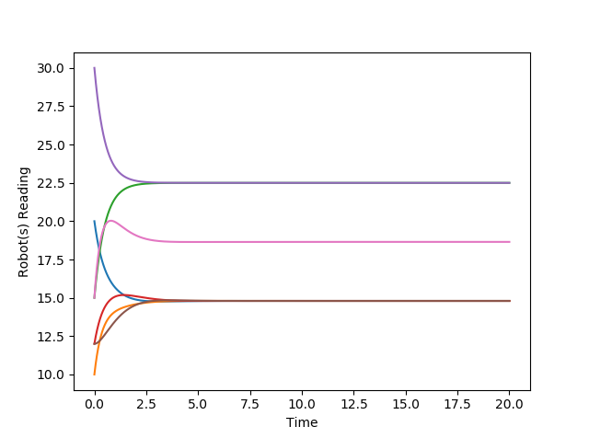

Graph (c) Graph (d)

**Exercise 2:**

1. To calculate the fixed points of this system, we need to find the solution for $\dot{x}=0 and \dot{y}=0$

$$\dot{x}=0 ⇒ -x+y=0⇒y=x$$

$$\dot{y}=0 ⇒ -x-y=0⇒y=-x$$

The only solution for the above two equations is $x=0 and y=0 i.e. \left(x,y\right)=(0,0)$

1. Given: $\dot{x}= -x+y=0 and \dot{y}= -x-y$

For $V_{1}\left(x,y\right)=\frac{1}{2}x^{2}+y^{2}$

Let us evaluate $\dot{V_{1}}$

$$\dot{V_{1}}=x\dot{x}+2y\dot{y}$$

$$⇒\dot{V_{1}}=x(-x+y)+2y(-x-y)$$

$$⇒\dot{V_{1}}=-x^{2}-xy-{2y}^{2}$$

$$⇒\dot{V_{1}}=-{\frac{x}{2}}^{2}-\frac{3}{2}y^{2}-{\left(\frac{x}{\sqrt{2}}+\frac{y}{\sqrt{2}}\right)}^{2}$$

**Since, ${\dot{V}}_{1}<0$ and , $V_{1}$ is positive definite. Therefore, it is a valid Lypunov function.**

For $V_{2}\left(x,y\right)=-x^{2}+100y^{2}$

**Since, $V_{2} ≯0$ i.e. it is not strictly positive definite . Therefore, it is not a valid Lypunov function.**

For $V_{3}\left(x,y\right)={\left(x-\frac{1}{2}y\right)}^{2}+\frac{7}{4}y^{2}$

Let us evaluate $\dot{V_{3}}$

$$\dot{V_{3}}=2\left(x-\frac{1}{2}y\right)\left(\dot{x}-\frac{1}{2}\dot{y}\right)+\frac{7}{2}y\dot{y}$$

$$⇒\dot{V_{3}}=2\left(x-\frac{1}{2}y\right)\left((-x+y)-\frac{1}{2}(-x-y)\right)+\frac{7}{2}y(-x-y)$$

$$⇒\dot{V_{3}}=-x^{2}+\frac{7}{2}xy-5y^{2}-\frac{7}{2}xy$$

$$⇒\dot{V_{3}}=-x^{2}-5y^{2}$$

**Since, ${\dot{V}}_{3}<0$ and , $V_{3}$ is positive definite. Therefore, it is a valid Lypunov function.**

With $V_{1} and V_{3}$ we can say that fixed point is **asymptotically stable.**

**Exercise 4:**

1. **Yes**, for each graph the consensus protocol will **converge** since, in all the cases the graph has **rooted out branching**. Since, it is also a **balanced** **digraph**, the consensus protocol will converge to **average** **value**.
2. **Yes**, even with switching the consensus protocol will **converge**  because at all the time the **union** of all the **graphs contain rooted out branching**.
3. Please refer to *‘simulateConsensusSwitch.py’*
4. 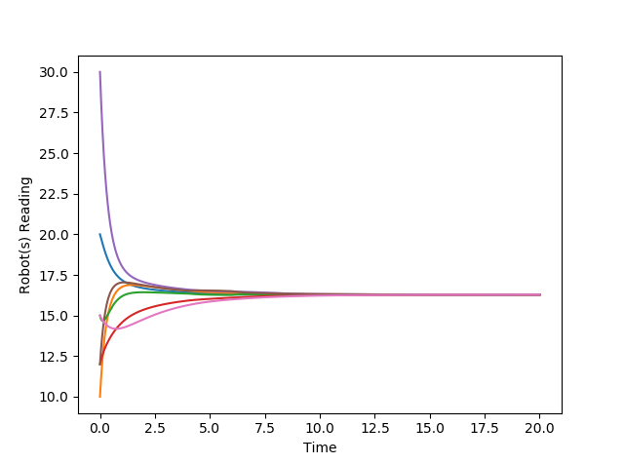We can see that with switch time = 2s plot is smooth in comparison to switch time = 0.1s

When switch time = 2s

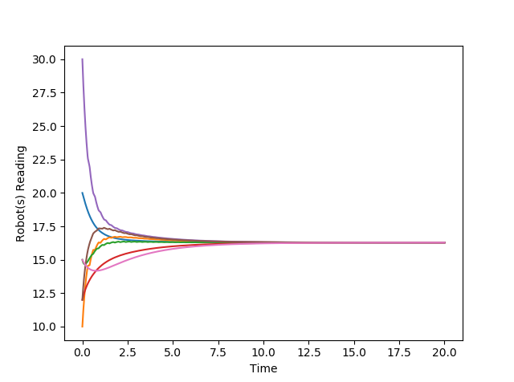

When switch time = 0.1s

**Exercise 5:**

1. **No**, for each graph the consensus protocol will **not** **converge** since, in all the cases the graph **doesn’t have rooted out branching**
2. **Yes**, with switching, the consensus protocol will **converge**  because at all the time the **union** of all the **graphs contain rooted out branching**.

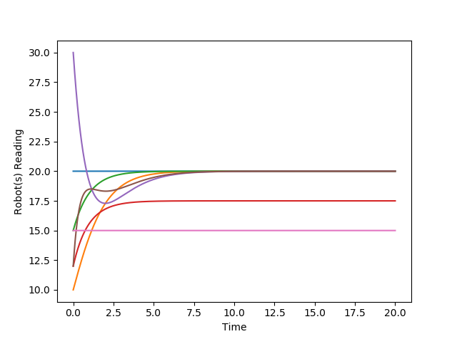

1. When no switching,

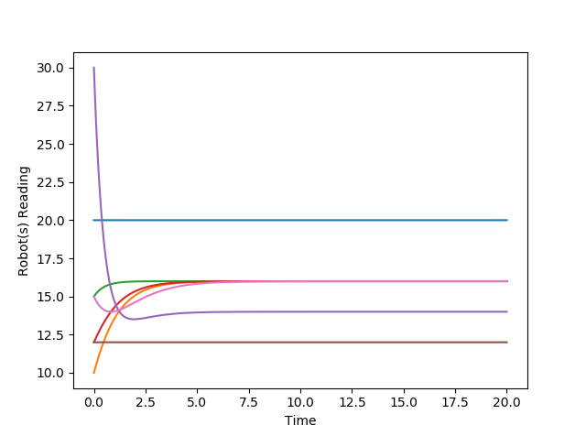 Graph (a)

Graph (b)

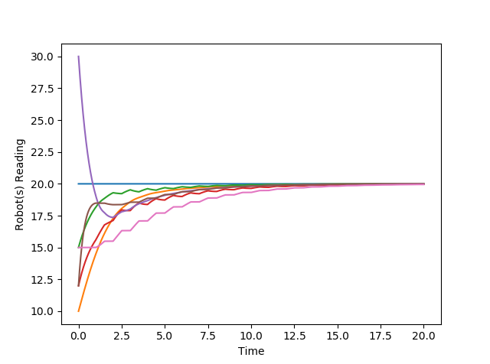 When switch time = 0.5 s

We ca see that in switching case it is converging while in non-switching case the consensus protocol will fail.

1. Following are the plots

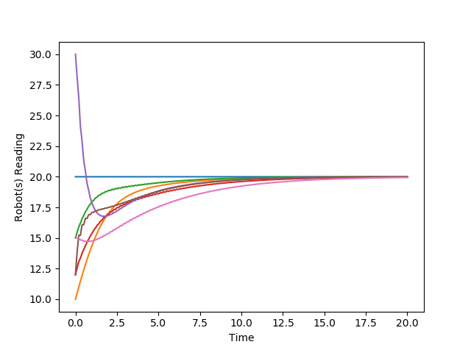Switch time = 0.1s

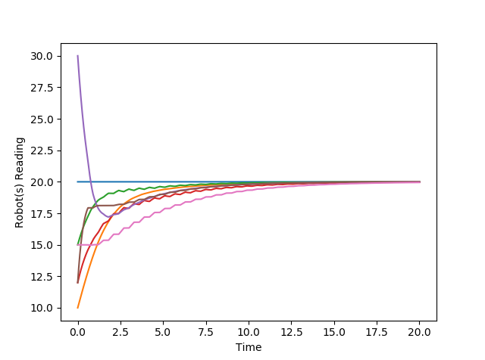Switch time = 0.3s

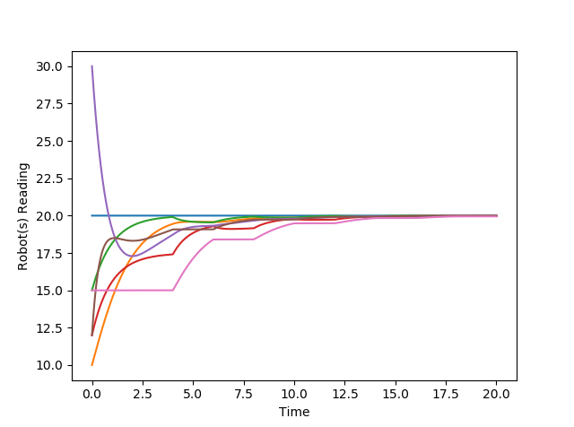

Switch time = 2s

We can see that when switch time is less, then the curves are smoother.

1. **1) No**, for each graph the consensus protocol will **not** **converge** since, in all the cases the graph **doesn’t have rooted out branching**

**2) Yes**, with switching, the consensus protocol will **converge**  because at all the time the **union** of all the **graphs contain rooted out branching**.

**3)** Whenno switching,

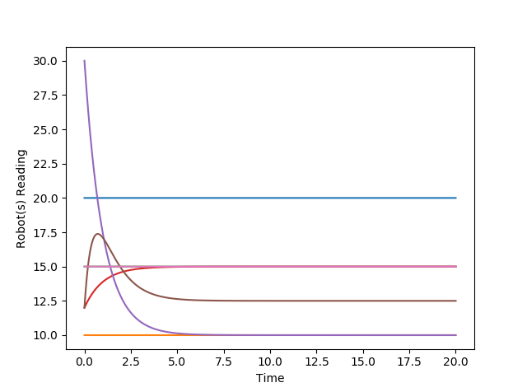

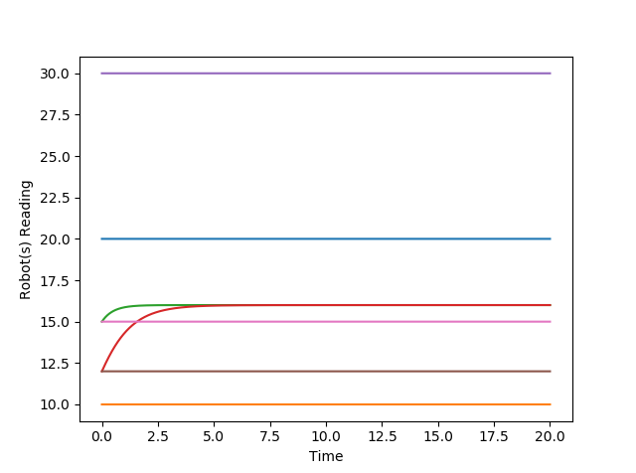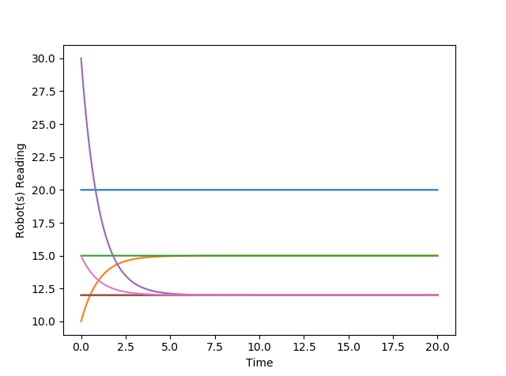 Graph(a)

Graph(b)

Graph(c)

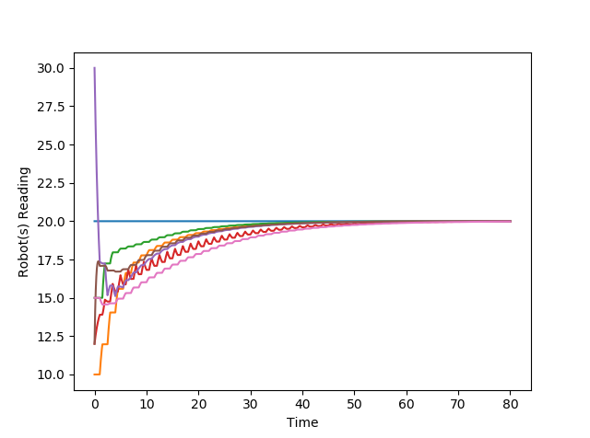 When switching time = 0.5s

**4)** Following are the plots

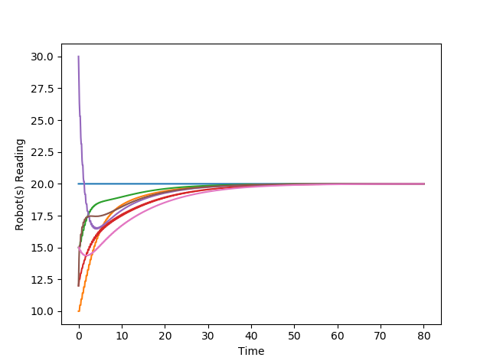 Switch time = 0.1 s

Switch time = 0.3 s

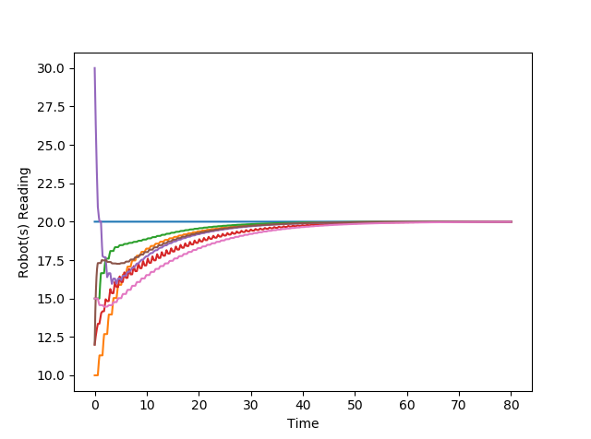

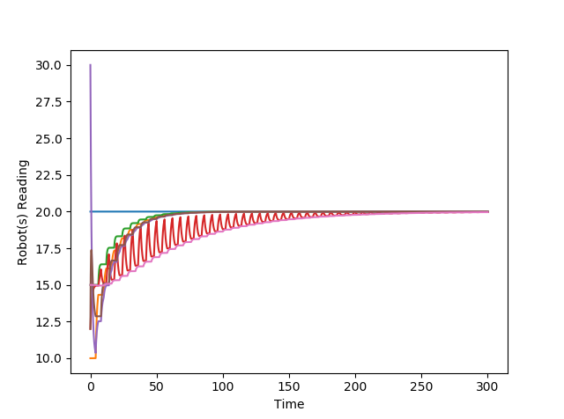

Switch time = 2s

We can see that which switching time less convergence is faster.